Fortinet

FortiGate Web Developer

Instructions

**FortiGate Web Developer Programming Test**

Fortinet is looking for Web Developers with a passion to improve and expand the user experience of the web interface of our FortiGate firewall. You will join a high energy team that is creating a compelling and innovative web-based firewall management system for a wide variety of users. As a Fortinet Web Developer, you will learn about the latest advancements in network security - including firewall configuration, VPN setup, WiFi network management and Unified Threat Management (Anti-Virus, Intrusion Protection, Web Filter, and Application Control).

**Please carefully read the below points before starting the test:**

* We estimate the test will take between 2 - 2.5 hours to complete. However, we have allotted 3 hours for the test in case you need the extra time.
* To get familiarized with the coding environment, try this [Sample Test](https://www.hackerrank.com/tests/b09fqmga9mf/70836a5318dc16eb8a513897b3eea5f4).
* Some questions allow you to write your answer in a set of different programming languages. You are welcome to choose the language you are most comfortable with.
* If the code area contains the function signature, just complete the function alone, we'll take care of the main function, headers, etc.
* To understand more about the environment, time limits, etc. you can read the [FAQ here](https://www.hackerrank.com/tests/info/faq).
* You can print to console to debug your code using the appropriate print command for each language.

Sample Test

## Questions

Feel free to choose your preferred programming language from the list of languages supported for each question.There are 4 questions that are part of this test:

| **Question Indexes** | **Question Types** |
| --- | --- |
| Q1 | **Frontend Question**Angular |
| Q2 | **HTML/CSS/JavaScript Question** |
| Q3 | **Coding Question**28 languages allowed: c, clojure, cpp, cpp14, cpp20, csharp, erlang, go, haskell, java, java15, java8, javascript, julia, kotlin, lua, objectivec, perl, php, pypy, pypy3, python, python3, r, ruby, scala, swift, typescript |
| Q4 | **Complete Sentence Question** |

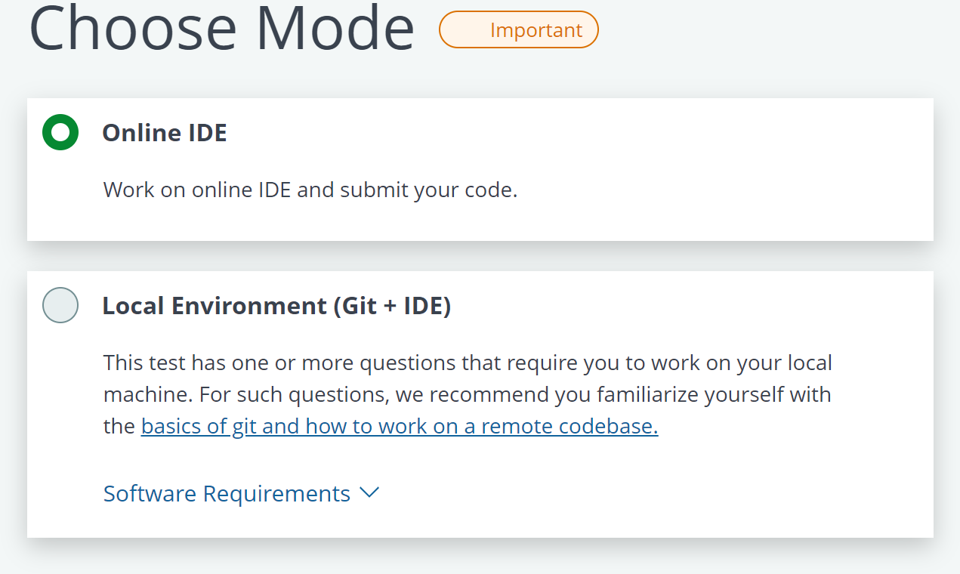

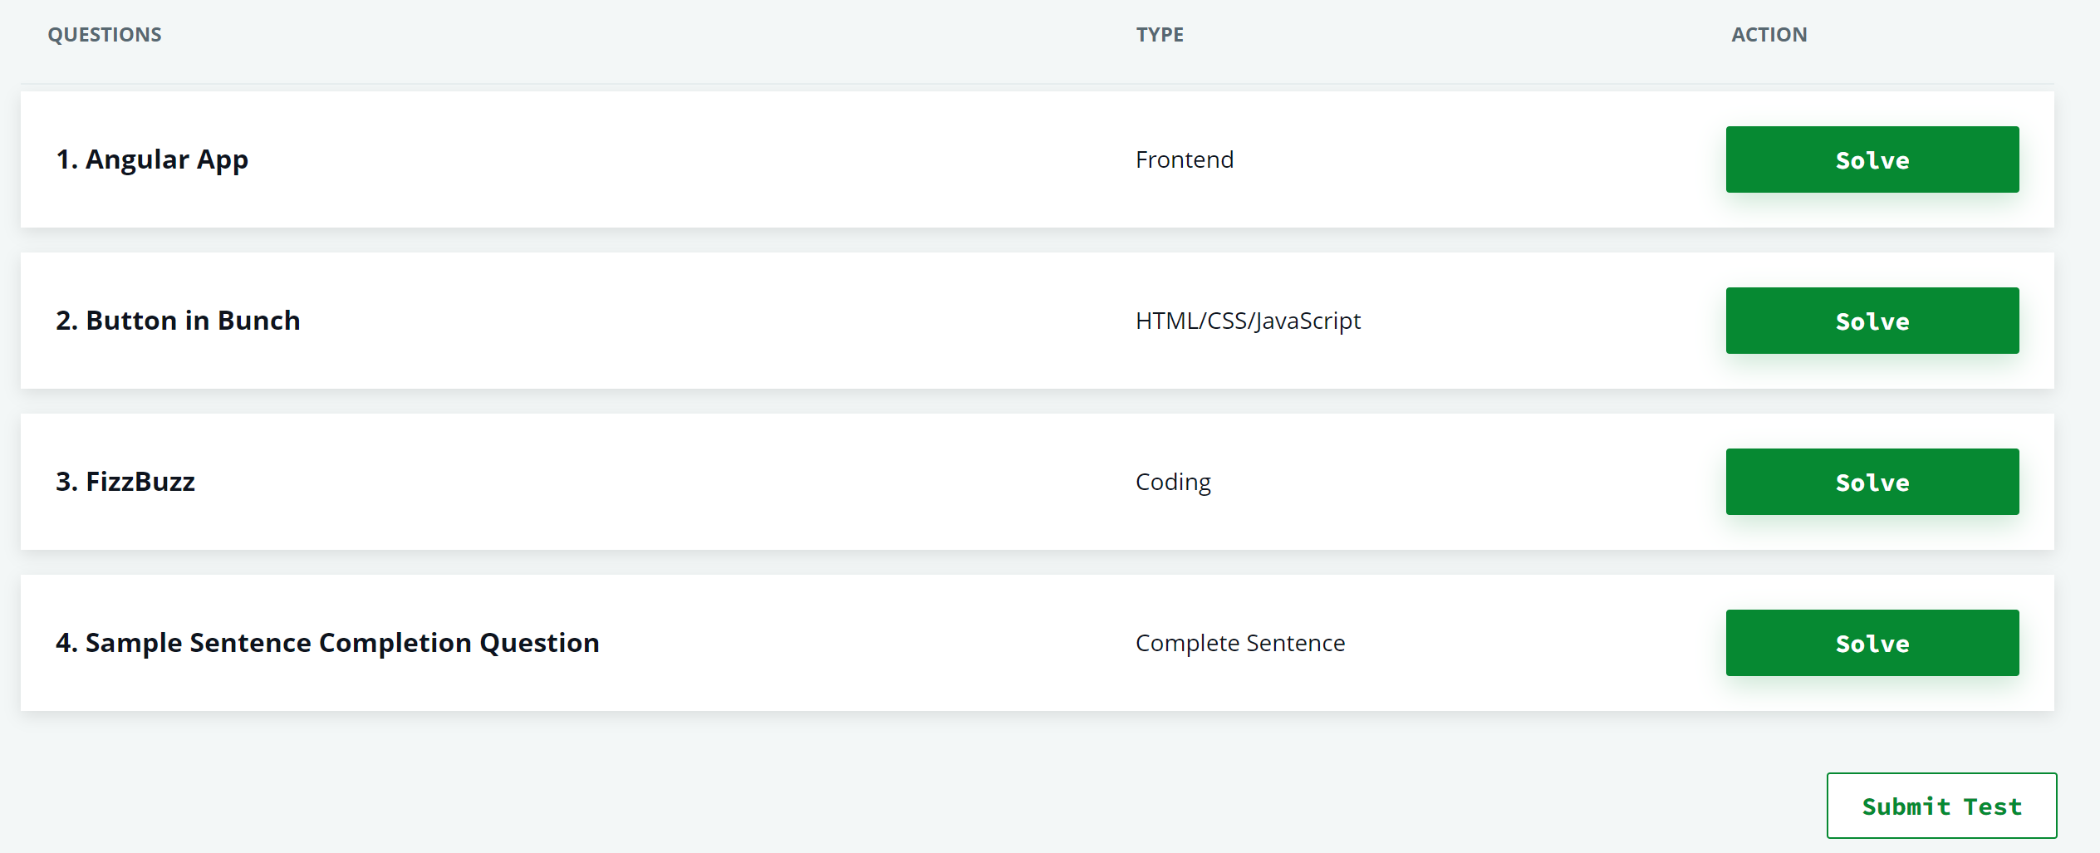

Question 1

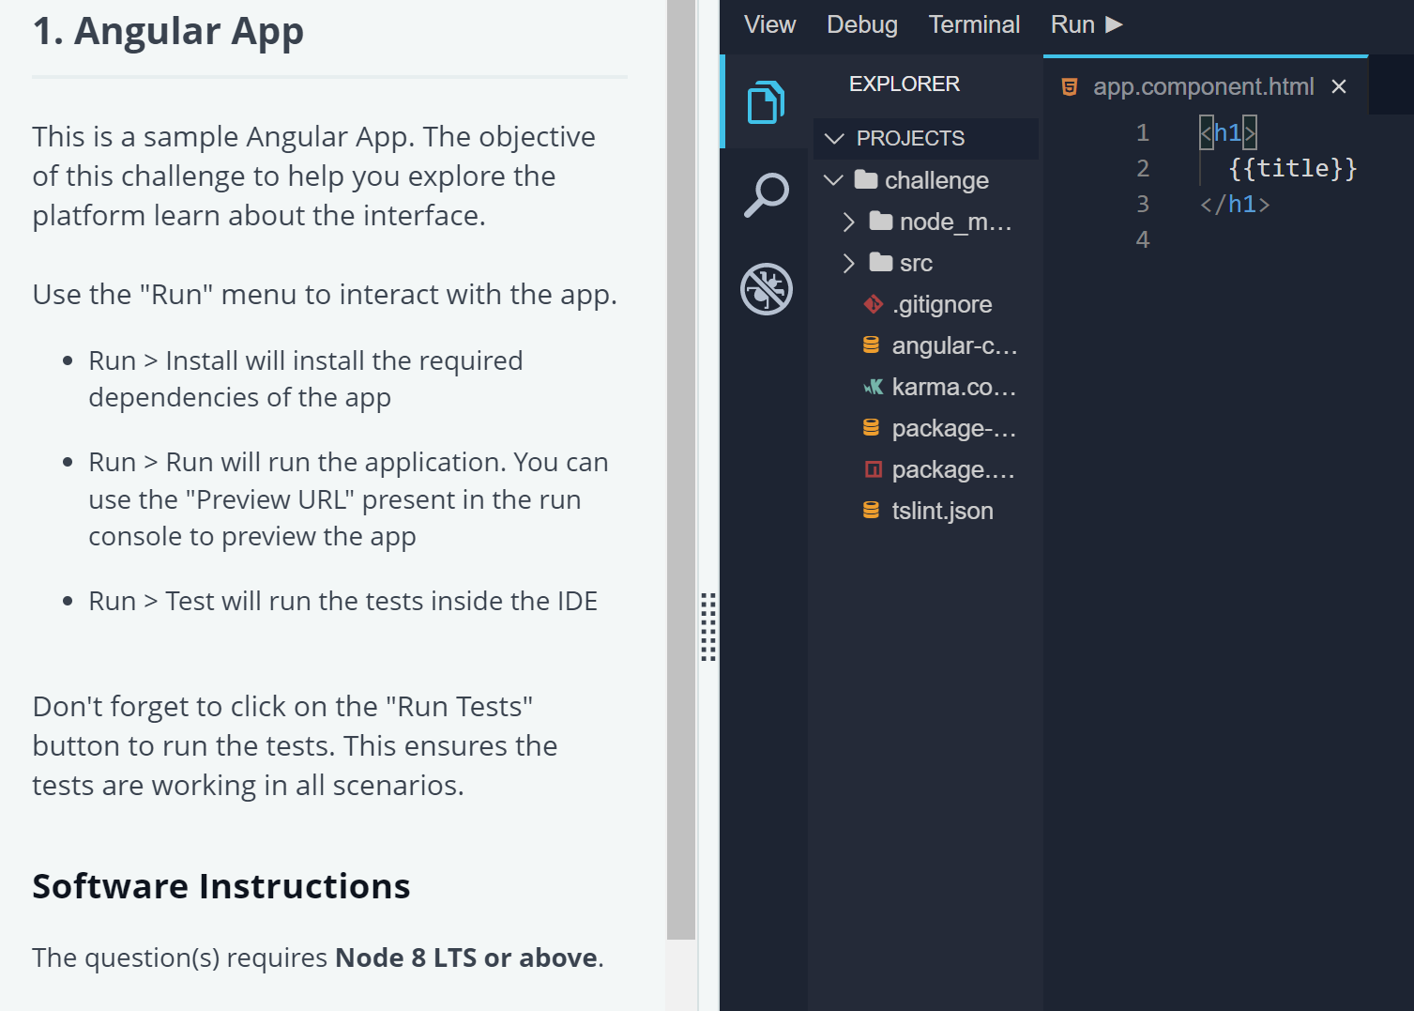

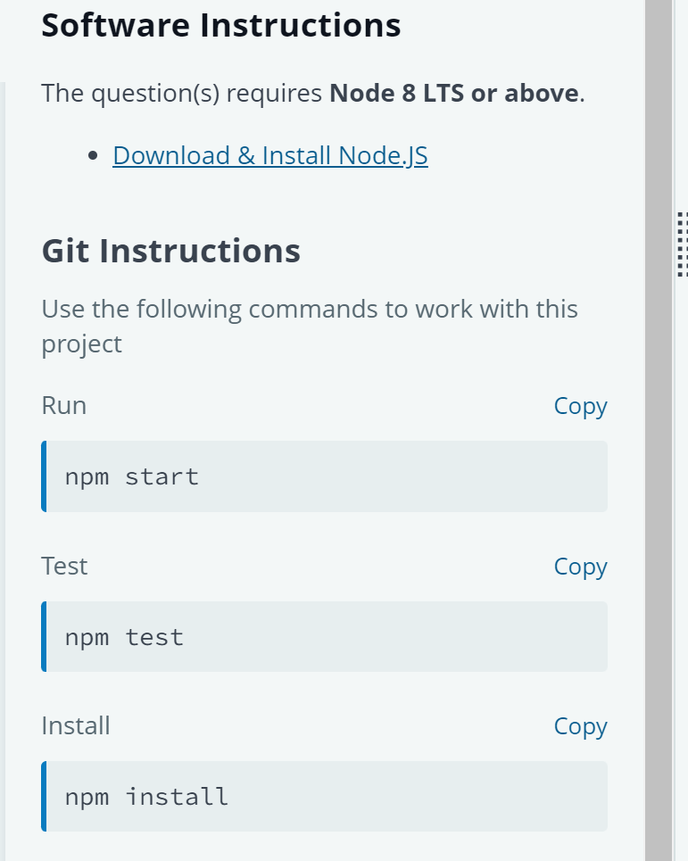

* Downloaded test folder

Question 2

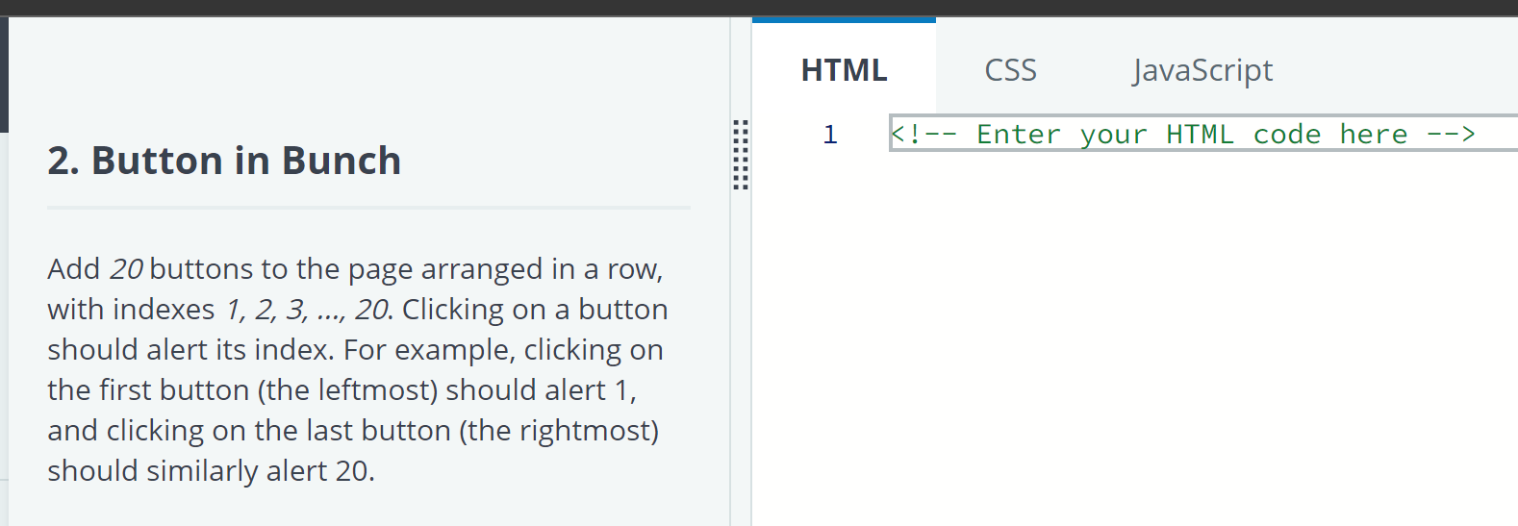

Question 3

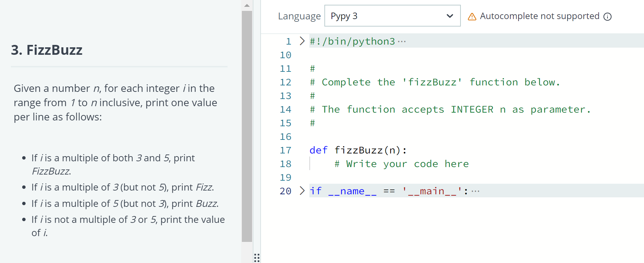

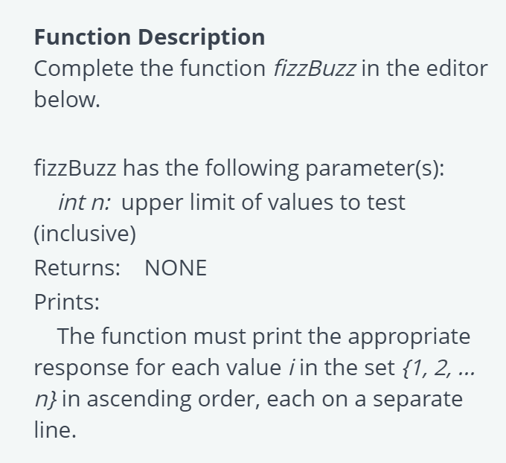

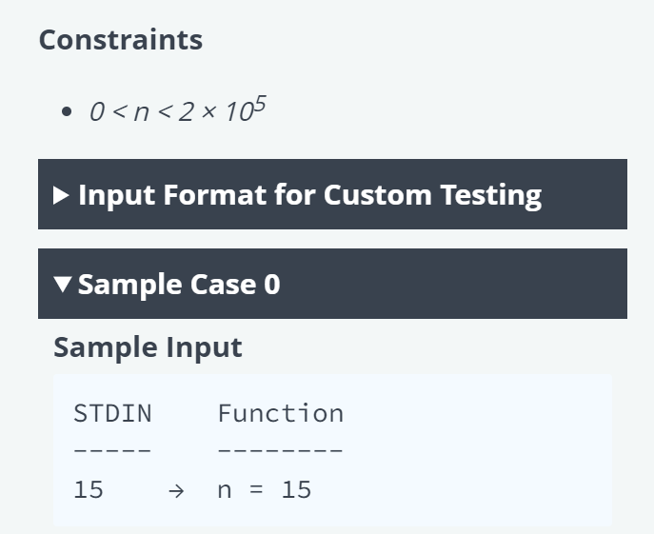

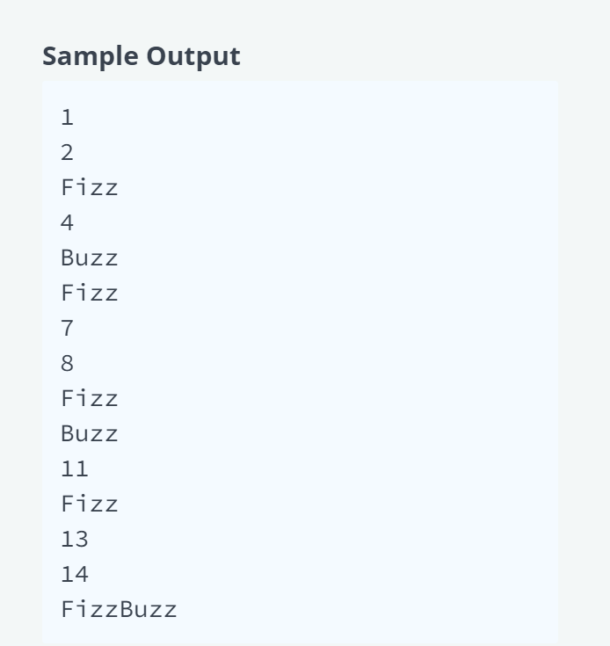

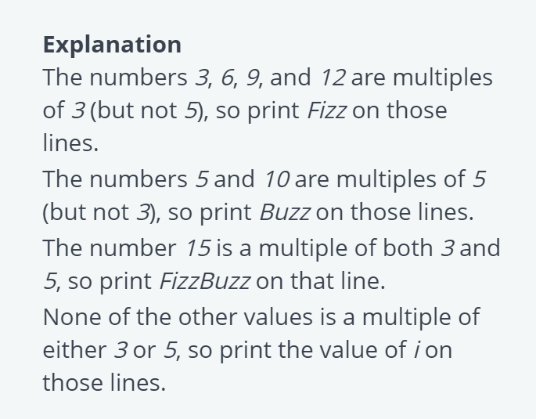

Question 4

